Practice sheet # 6

1. (a) Determine the Fourier series for
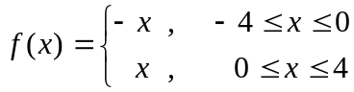 Period = 8 .
(b)Find the Fourier coefficients for
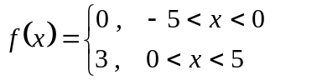Period = 10 .
2. (a) Determine the Fourier series for 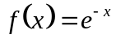 in the interval 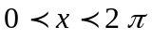 .
(b)Determine the Fourier series for 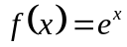 in the interval 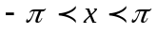 .
3. Expand 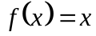 , 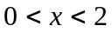 in a half – range
(i) Sine series (ii) Cosine series .
4. Find the Fourier series expansion of the function 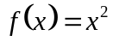 in the interval
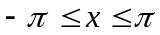 and hence evaluate 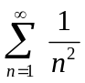 .
5. (a) Determine the Fourier series of the function
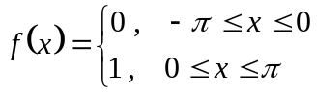 .
(b) Determine the Complex form of the Fourier series of the function
.
6. Expand 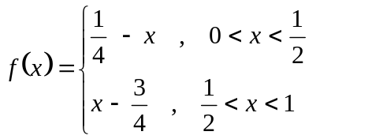, in a Fourier series of Sine terms only.
7. Find the Fourier transform of 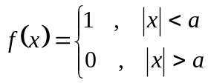
8. (a) Determine the Fourier Cosine transform of 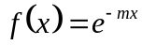 , m > 0
(b) Use the result in (a) show that 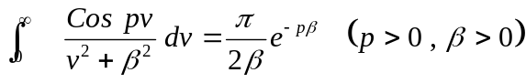 .
9. The Fourier transform w . r . to the variable x , show that
(i) 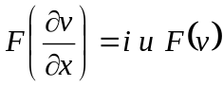 (ii) 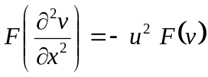 (iii) )  

